**UNIT-III**

First-Order Logic in Artificial intelligence

In the topic of Propositional logic, we have seen that how to represent statements using propositional logic. But unfortunately, in propositional logic, we can only represent the facts, which are either true or false. PL is not sufficient to represent the complex sentences or natural language statements. The propositional logic has very limited expressive power. Consider the following sentence, which we cannot represent using PL logic.

* **"Some humans are intelligent", or**
* **"Sachin likes cricket."**

To represent the above statements, PL logic is not sufficient, so we required some more powerful logic, such as first-order logic.

## **First-Order logic:**

* First-order logic is another way of knowledge representation in artificial intelligence. It is an extension to propositional logic.
* FOL is sufficiently expressive to represent the natural language statements in a concise way.
* First-order logic is also known as **Predicate logic or First-order predicate logic**. First-order logic is a powerful language that develops information about the objects in a more easy way and can also express the relationship between those objects.
* First-order logic (like natural language) does not only assume that the world contains facts like propositional logic but also assumes the following things in the world:
  + **Objects:** A, B, people, numbers, colors, wars, theories, squares, pits, wumpus, ......
  + **Relations:** **It can be unary relation such as:** red, round, is adjacent, **or n-any relation such as:** the sister of, brother of, has color, comes between
  + **Function:** Father of, best friend, third inning of, end of, ......
* As a natural language, first-order logic also has two main parts:
  + **Syntax**
  + **Semantics**

## **Syntax of First-Order logic:**

The syntax of FOL determines which collection of symbols is a logical expression in first-order logic. The basic syntactic elements of first-order logic are symbols. We write statements in short-hand notation in FOL.

### **Basic Elements of First-order logic:**

|  |  |
| --- | --- |
| **Constant** | 1, 2, A, John, Mumbai, cat,.... |
| **Variables** | x, y, z, a, b,.... |
| **Predicates** | Brother, Father, >,.... |
| **Function** | sqrt, LeftLegOf, .... |
| **Connectives** | ∧, ∨, ¬, ⇒, ⇔ |
| **Equality** | == |
| **Quantifier** | ∀, ∃ |

Following are the basic elements of FOL syntax:

### **Atomic sentences:**

* Atomic sentences are the most basic sentences of first-order logic. These sentences are formed from a predicate symbol followed by a parenthesis with a sequence of terms.
* We can represent atomic sentences as **Predicate (term1, term2, ......, term n)**.

**Example: Ravi and Ajay are brothers: => Brothers(Ravi, Ajay).  
                Chinky is a cat: => cat (Chinky)**.

### **Complex Sentences:**

* Complex sentences are made by combining atomic sentences using connectives.

**First-order logic statements can be divided into two parts:**

* **Subject:** Subject is the main part of the statement.
* **Predicate:** A predicate can be defined as a relation, which binds two atoms together in a statement.

**Consider the statement: "x is an integer."**, it consists of two parts, the first part x is the subject of the statement and second part "is an integer," is known as a predicate.

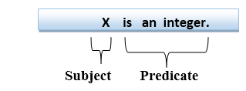

## **Quantifiers in First-order logic:**

* A quantifier is a language element which generates quantification, and quantification specifies the quantity of specimen in the universe of discourse.
* These are the symbols that permit to determine or identify the range and scope of the variable in the logical expression. There are two types of quantifier:
  1. **Universal Quantifier, (for all, everyone, everything)**
  2. **Existential quantifier, (for some, at least one).**

### **Universal Quantifier:**

Universal quantifier is a symbol of logical representation, which specifies that the statement within its range is true for everything or every instance of a particular thing.

The Universal quantifier is represented by a symbol ∀, which resembles an inverted A.

#### **Note: In universal quantifier we use implication "→".**

If x is a variable, then ∀x is read as:

* **For all x**
* **For each x**
* **For every x.**

### **Example:**

**All man drink coffee.**

Let a variable x which refers to a cat so all x can be represented in UOD as below:

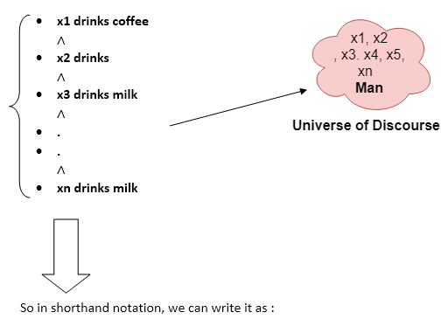

**∀x man(x) → drink (x, coffee).**

It will be read as: There are all x where x is a man who drink coffee.

## **Existential Quantifier:**

Existential quantifiers are the type of quantifiers, which express that the statement within its scope is true for at least one instance of something.

It is denoted by the logical operator ∃, which resembles as inverted E. When it is used with a predicate variable then it is called as an existential quantifier.

#### **Note: In Existential quantifier we always use AND or Conjunction symbol (∧).**

If x is a variable, then existential quantifier will be ∃x or ∃(x). And it will be read as:

* **There exists a 'x.'**
* **For some 'x.'**
* **For at least one 'x.'**

### **Example:**

**Some boys are intelligent.**

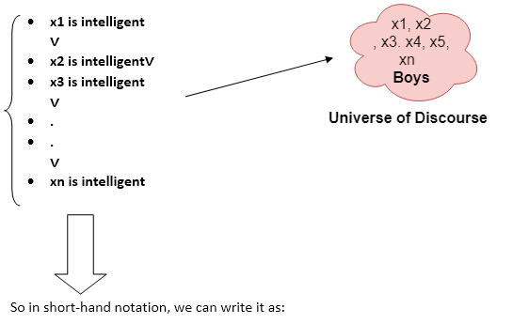

**∃x: boys(x) ∧ intelligent(x)**

It will be read as: There are some x where x is a boy who is intelligent.

## **Points to remember:**

* The main connective for universal quantifier **∀** is implication **→**.
* The main connective for existential quantifier **∃** is and **∧**.

## **Properties of Quantifiers:**

* In universal quantifier, ∀x∀y is similar to ∀y∀x.
* In Existential quantifier, ∃x∃y is similar to ∃y∃x.
* ∃x∀y is not similar to ∀y∃x.

Some Examples of FOL using quantifier:

**1. All birds fly.**  
In this question the predicate is "**fly(bird)**."  
And since there are all birds who fly so it will be represented as follows.  
              **∀x bird(x) →fly(x)**.

**2. Every man respects his parent.**  
In this question, the predicate is "**respect(x, y)," where x=man, and y= parent**.  
Since there is every man so will use ∀, and it will be represented as follows:  
              **∀x man(x) → respects (x, parent)**.

**3. Some boys play cricket.**  
In this question, the predicate is "**play(x, y)**," where x= boys, and y= game. Since there are some boys so we will use **∃, and it will be represented as**:  
              **∃x boys(x) → play(x, cricket)**.

**4. Not all students like both Mathematics and Science.**  
In this question, the predicate is "**like(x, y)," where x= student, and y= subject**.  
Since there are not all students, so we will use **∀ with negation, so** following representation for this:  
              **¬∀ (x) [ student(x) → like(x, Mathematics) ∧ like(x, Science)].**

**5. Only one student failed in Mathematics.**  
In this question, the predicate is "**failed(x, y)," where x= student, and y= subject**.  
Since there is only one student who failed in Mathematics, so we will use following representation for this:  
              **∃(x) [ student(x) → failed (x, Mathematics) ∧∀ (y) [¬(x==y) ∧ student(y) → ¬failed (x, Mathematics)]**.

## **Free and Bound Variables:**

The quantifiers interact with variables which appear in a suitable way. There are two types of variables in First-order logic which are given below:

**Free Variable:** A variable is said to be a free variable in a formula if it occurs outside the scope of the quantifier.

**Example: ∀x ∃(y)[P (x, y, z)], where z is a free variable.**

**Bound Variable:** A variable is said to be a bound variable in a formula if it occurs within the scope of the quantifier.

**Example: ∀x [A (x) B( y)], here x and y are the bound variables.**

# Knowledge Engineering in First-order logic

## **What is knowledge-engineering?**

The process of constructing a knowledge-base in first-order logic is called as knowledge- engineering. In **knowledge-engineering**, someone who investigates a particular domain, learns important concept of that domain, and generates a formal representation of the objects, is known as **knowledge engineer**.

In this topic, we will understand the Knowledge engineering process in an electronic circuit domain, which is already familiar. This approach is mainly suitable for creating **special-purpose knowledge base**.

## **The knowledge-engineering process:**

Following are some main steps of the knowledge-engineering process. Using these steps, we will develop a knowledge base which will allow us to reason about digital circuit (**One-bit full adder**) which is given below

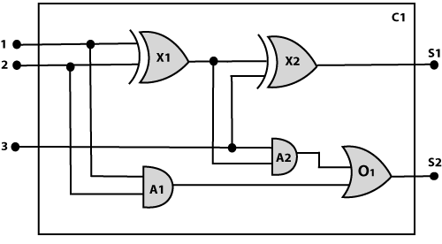

### **1. Identify the task:**

The first step of the process is to identify the task, and for the digital circuit, there are various reasoning tasks.

At the first level or highest level, we will examine the functionality of the circuit:

* **Does the circuit add properly?**
* **What will be the output of gate A2, if all the inputs are high?**

At the second level, we will examine the circuit structure details such as:

* **Which gate is connected to the first input terminal?**
* **Does the circuit have feedback loops?**

### **2. Assemble the relevant knowledge:**

In the second step, we will assemble the relevant knowledge which is required for digital circuits. So for digital circuits, we have the following required knowledge:

* Logic circuits are made up of wires and gates.
* Signal flows through wires to the input terminal of the gate, and each gate produces the corresponding output which flows further.
* In this logic circuit, there are four types of gates used: **AND, OR, XOR, and NOT**.
* All these gates have one output terminal and two input terminals (except NOT gate, it has one input terminal).

### **3. Decide on vocabulary:**

The next step of the process is to select functions, predicate, and constants to represent the circuits, terminals, signals, and gates. Firstly we will distinguish the gates from each other and from other objects. Each gate is represented as an object which is named by a constant, such as, **Gate(X1)**. The functionality of each gate is determined by its type, which is taken as constants such as **AND, OR, XOR, or NOT**. Circuits will be identified by a predicate: **Circuit (C1)**.

For the terminal, we will use predicate: **Terminal(x)**.

For gate input, we will use the function **In(1, X1)** for denoting the first input terminal of the gate, and for output terminal we will use **Out (1, X1)**.

The function **Arity(c, i, j)** is used to denote that circuit c has i input, j output.

The connectivity between gates can be represented by predicate **Connect(Out(1, X1), In(1, X1))**.

We use a unary predicate **On (t)**, which is true if the signal at a terminal is on.

### **4. Encode general knowledge about the domain:**

To encode the general knowledge about the logic circuit, we need some following rules:

* If two terminals are connected then they have the same input signal, it can be represented as:

1. ∀  t1, t2 Terminal (t1) ∧ Terminal (t2) ∧ Connect (t1, t2) → Signal (t1) = Signal (2).

* Signal at every terminal will have either value 0 or 1, it will be represented as:

1. ∀  t Terminal (t) →Signal (t) = 1 ∨Signal (t) = 0.

* Connect predicates are commutative:

1. ∀  t1, t2 Connect(t1, t2)  →  Connect (t2, t1).

* Representation of types of gates:

1. ∀  g Gate(g) ∧ r = Type(g) → r = OR ∨r = AND ∨r = XOR ∨r = NOT.

* Output of AND gate will be zero if and only if any of its input is zero.

1. ∀  g Gate(g) ∧ Type(g) = AND →Signal (Out(1, g))= 0 ⇔  ∃n Signal (In(n, g))= 0.

* Output of OR gate is 1 if and only if any of its input is 1:

1. ∀  g Gate(g) ∧ Type(g) = OR → Signal (Out(1, g))= 1 ⇔  ∃n Signal (In(n, g))= 1

* Output of XOR gate is 1 if and only if its inputs are different:

1. ∀  g Gate(g) ∧ Type(g) = XOR → Signal (Out(1, g)) = 1 ⇔  Signal (In(1, g)) ≠ Signal (In(2, g)).

* Output of NOT gate is invert of its input:

1. ∀  g Gate(g) ∧ Type(g) = NOT →   Signal (In(1, g)) ≠ Signal (Out(1, g)).

* All the gates in the above circuit have two inputs and one output (except NOT gate).

1. ∀  g Gate(g) ∧ Type(g) = NOT →   Arity(g, 1, 1)
2. ∀  g Gate(g) ∧ r =Type(g)  ∧ (r= AND ∨r= OR ∨r= XOR) →  Arity (g, 2, 1).

* All gates are logic circuits:

1. ∀  g Gate(g) → Circuit (g).

### **5. Encode a description of the problem instance:**

Now we encode problem of circuit C1, firstly we categorize the circuit and its gate components. This step is easy if ontology about the problem is already thought. This step involves the writing simple atomics sentences of instances of concepts, which is known as ontology.

For the given circuit C1, we can encode the problem instance in atomic sentences as below:

Since in the circuit there are two XOR, two AND, and one OR gate so atomic sentences for these gates will be:

1. For XOR gate: Type(x1)= XOR, Type(X2) = XOR
2. For AND gate: Type(A1) = AND, Type(A2)= AND
3. For OR gate: Type (O1) = OR.

And then represent the connections between all the gates.

#### **Note: Ontology defines a particular theory of the nature of existence.**

### **6. Pose queries to the inference procedure and get answers:**

In this step, we will find all the possible set of values of all the terminal for the adder circuit. The first query will be:

What should be the combination of input which would generate the first output of circuit C1, as 0 and a second output to be 1?

1. ∃ i1, i2, i3 Signal (In(1, C1))=i1  ∧  Signal (In(2, C1))=i2  ∧ Signal (In(3, C1))= i3
2. ∧ Signal (Out(1, C1)) =0 ∧ Signal (Out(2, C1))=1

### **7. Debug the knowledge base:**

Now we will debug the knowledge base, and this is the last step of the complete process. In this step, we will try to debug the issues of knowledge base.

In the knowledge base, we may have omitted assertions like 1 ≠ 0.

# Inference in First-Order Logic

Inference in First-Order Logic is used to deduce new facts or sentences from existing sentences. Before understanding the FOL inference rule, let's understand some basic terminologies used in FOL.

**Substitution:**

Substitution is a fundamental operation performed on terms and formulas. It occurs in all inference systems in first-order logic. The substitution is complex in the presence of quantifiers in FOL. If we write **F[a/x]**, so it refers to substitute a constant "**a**" in place of variable "**x**".

#### **Note: First-order logic is capable of expressing facts about some or all objects in the universe.**

**Equality:**

First-Order logic does not only use predicate and terms for making atomic sentences but also uses another way, which is equality in FOL. For this, we can use **equality symbols** which specify that the two terms refer to the same object.

**Example: Brother (John) = Smith.**

As in the above example, the object referred by the **Brother (John)** is similar to the object referred by **Smith**. The equality symbol can also be used with negation to represent that two terms are not the same objects.

**Example: ￢(x=y) which is equivalent to x ≠y.**

## **FOL inference rules for quantifier:**

As propositional logic we also have inference rules in first-order logic, so following are some basic inference rules in FOL:

* **Universal Generalization**
* **Universal Instantiation**
* **Existential Instantiation**
* **Existential introduction**

**1. Universal Generalization:**

* Universal generalization is a valid inference rule which states that if premise P(c) is true for any arbitrary element c in the universe of discourse, then we can have a conclusion as ∀ x P(x).
* It can be represented as: Inference in First-Order Logic.
* This rule can be used if we want to show that every element has a similar property.
* In this rule, x must not appear as a free variable.

**Example:** Let's represent, P(c): "**A byte contains 8 bits**", so for **∀ x P(x)** "**All bytes contain 8 bits**.", it will also be true.

**2. Universal Instantiation:**

* Universal instantiation is also called as universal elimination or UI is a valid inference rule. It can be applied multiple times to add new sentences.
* The new KB is logically equivalent to the previous KB.
* As per UI, **we can infer any sentence obtained by substituting a ground term for the variable**.
* The UI rule state that we can infer any sentence P(c) by substituting a ground term c (a constant within domain x) from **∀ x P(x) for any object in the universe of discourse**.
* It can be represented as:Inference in First-Order Logic.

**Example:1.**

IF "Every person like ice-cream"=> ∀x P(x) so we can infer that  
"John likes ice-cream" => P(c)

**Example: 2.**

Let's take a famous example,

"All kings who are greedy are Evil." So let our knowledge base contains this detail as in the form of FOL:

**∀x king(x) ∧ greedy (x) → Evil (x),**

So from this information, we can infer any of the following statements using Universal Instantiation:

* **King(John) ∧ Greedy (John) → Evil (John),**
* **King(Richard) ∧ Greedy (Richard) → Evil (Richard),**
* **King(Father(John)) ∧ Greedy (Father(John)) → Evil (Father(John)),**

**3. Existential Instantiation:**

ADVERTISEMENT

* Existential instantiation is also called as Existential Elimination, which is a valid inference rule in first-order logic.
* It can be applied only once to replace the existential sentence.
* The new KB is not logically equivalent to old KB, but it will be satisfiable if old KB was satisfiable.
* This rule states that one can infer P(c) from the formula given in the form of ∃x P(x) for a new constant symbol c.
* The restriction with this rule is that c used in the rule must be a new term for which P(c ) is true.
* It can be represented as:Inference in First-Order Logic

**Example:**

From the given sentence: **∃x Crown(x) ∧ OnHead(x, John),**

ADVERTISEMENT

ADVERTISEMENT

So we can infer: **Crown(K) ∧ OnHead( K, John),** as long as K does not appear in the knowledge base.

* The above used K is a constant symbol, which is called **Skolem constant**.
* The Existential instantiation is a special case of **Skolemization process**.

**4. Existential introduction**

* An existential introduction is also known as an existential generalization, which is a valid inference rule in first-order logic.
* This rule states that if there is some element c in the universe of discourse which has a property P, then we can infer that there exists something in the universe which has the property P.
* It can be represented as: Inference in First-Order Logic
* **Example: Let's say that,**  
  "Priyanka got good marks in English."  
  "Therefore, someone got good marks in English."

## **Generalized Modus Ponens Rule:**

For the inference process in FOL, we have a single inference rule which is called Generalized Modus Ponens. It is lifted version of Modus ponens.

Generalized Modus Ponens can be summarized as, " P implies Q and P is asserted to be true, therefore Q must be True."

According to Modus Ponens, for atomic sentences **pi, pi', q**. Where there is a substitution θ such that SUBST **(θ, pi',) = SUBST(θ, pi)**, it can be represented as:

Inference in First-Order Logic

**Example:**

**We will use this rule for Kings are evil, so we will find some x such that x is king, and x is greedy so we can infer that x is evil.**

1. Here let say, p1' is king(John)        p1 is king(x)
2. p2' is Greedy(y)                       p2 is Greedy(x)
3. θ is {x/John, y/John}                  q is evil(x)
4. SUBST(θ,q).

# What is Unification?

* Unification is a process of making two different logical atomic expressions identical by finding a substitution. Unification depends on the substitution process.
* It takes two literals as input and makes them identical using substitution.
* Let Ψ1 and Ψ2 be two atomic sentences and 𝜎 be a unifier such that, **Ψ1𝜎 = Ψ2𝜎**, then it can be expressed as **UNIFY(Ψ1, Ψ2)**.
* **Example: Find the MGU for Unify{King(x), King(John)}**

Let Ψ1 = King(x), Ψ2 = King(John),

**Substitution θ = {John/x}** is a unifier for these atoms and applying this substitution, and both expressions will be identical.

* The UNIFY algorithm is used for unification, which takes two atomic sentences and returns a unifier for those sentences (If any exist).
* Unification is a key component of all first-order inference algorithms.
* It returns fail if the expressions do not match with each other.
* The substitution variables are called Most General Unifier or MGU.

**E.g.** Let's say there are two different expressions, **P(x, y), and P(a, f(z))**.

In this example, we need to make both above statements identical to each other. For this, we will perform the substitution.

ADVERTISEMENT

            P(x, y)......... (i)  
            P(a, f(z))......... (ii)

* Substitute x with a, and y with f(z) in the first expression, and it will be represented as **a/x** and f(z)/y.
* With both the substitutions, the first expression will be identical to the second expression and the substitution set will be: **[a/x, f(z)/y]**.

## **Conditions for Unification:**

**Following are some basic conditions for unification:**

* Predicate symbol must be same, atoms or expression with different predicate symbol can never be unified.
* Number of Arguments in both expressions must be identical.
* Unification will fail if there are two similar variables present in the same expression.

## **Unification Algorithm:**

**Algorithm: Unify(Ψ1, Ψ2)**

Step. 1: If Ψ1 or Ψ2 is a variable or constant, then:

a) If Ψ1 or Ψ2 are identical, then return NIL.

b) Else if Ψ1is a variable,

a. then if Ψ1 occurs in Ψ2, then return FAILURE

b. Else return { (Ψ2/ Ψ1)}.

c) Else if Ψ2 is a variable,

a. If Ψ2 occurs in Ψ1 then return FAILURE,

b. Else return {( Ψ1/ Ψ2)}.

d) Else return FAILURE.

Step.2: If the initial Predicate symbol in Ψ1 and Ψ2 are not same, then return FAILURE.

Step. 3: IF Ψ1 and Ψ2 have a different number of arguments, then return FAILURE.

Step. 4: Set Substitution set(SUBST) to NIL.

Step. 5: For i=1 to the number of elements in Ψ1.

a) Call Unify function with the ith element of Ψ1 and ith element of Ψ2, and put the result into S.

b) If S = failure then returns Failure

c) If S ≠ NIL then do,

a. Apply S to the remainder of both L1 and L2.

b. SUBST= APPEND(S, SUBST).

Step.6: Return SUBST.

## **Implementation of the Algorithm**

**Step.1:** Initialize the substitution set to be empty.

**Step.2:** Recursively unify atomic sentences:

1. Check for Identical expression match.
2. If one expression is a variable vi, and the other is a term ti which does not contain variable vi, then:
   1. Substitute ti / vi in the existing substitutions
   2. Add ti /vi to the substitution setlist.
   3. If both the expressions are functions, then function name must be similar, and the number of arguments must be the same in both the expression.

**For each pair of the following atomic sentences find the most general unifier (If exist).**

**1. Find the MGU of {p(f(a), g(Y)) and p(X, X)}**

            Sol: S0 => Here, Ψ1 = p(f(a), g(Y)), and Ψ2 = p(X, X)  
                  SUBST θ= {f(a) / X}  
                  S1 => Ψ1 = p(f(a), g(Y)), and Ψ2 = p(f(a), f(a))  
                  SUBST θ= {f(a) / g(y)}, **Unification failed**.

Unification is not possible for these expressions.

**2. Find the MGU of {p(b, X, f(g(Z))) and p(Z, f(Y), f(Y))}**

Here, Ψ1 = p(b, X, f(g(Z))) , and Ψ2 = p(Z, f(Y), f(Y))  
S0 => { p(b, X, f(g(Z))); p(Z, f(Y), f(Y))}  
SUBST θ={b/Z}

S1 => { p(b, X, f(g(b))); p(b, f(Y), f(Y))}  
SUBST θ={f(Y) /X}

S2 => { p(b, f(Y), f(g(b))); p(b, f(Y), f(Y))}  
SUBST θ= {g(b) /Y}

S2 => { p(b, f(g(b)), f(g(b)); p(b, f(g(b)), f(g(b))} **Unified Successfully.  
And Unifier = { b/Z, f(Y) /X , g(b) /Y}**.

**3. Find the MGU of {p (X, X), and p (Z, f(Z))}**

Here, Ψ1 = {p (X, X), and Ψ2 = p (Z, f(Z))  
S0 => {p (X, X), p (Z, f(Z))}  
SUBST θ= {X/Z}  
              S1 => {p (Z, Z), p (Z, f(Z))}  
SUBST θ= {f(Z) / Z}, **Unification Failed**.

**Hence, unification is not possible for these expressions.**

**4. Find the MGU of UNIFY(prime (11), prime(y))**

Here, Ψ1 = {prime(11) , and Ψ2 = prime(y)}  
S0 => {prime(11) , prime(y)}  
SUBST θ= {11/y}

S1 => {prime(11) , prime(11)} , **Successfully unified.**  
              **Unifier: {11/y}.**

**5. Find the MGU of Q(a, g(x, a), f(y)), Q(a, g(f(b), a), x)}**

Here, Ψ1 = Q(a, g(x, a), f(y)), and Ψ2 = Q(a, g(f(b), a), x)  
S0 => {Q(a, g(x, a), f(y)); Q(a, g(f(b), a), x)}  
SUBST θ= {f(b)/x}  
S1 => {Q(a, g(f(b), a), f(y)); Q(a, g(f(b), a), f(b))}

SUBST θ= {b/y}  
S1 => {Q(a, g(f(b), a), f(b)); Q(a, g(f(b), a), f(b))}, **Successfully Unified.**

**Unifier: [a/a, f(b)/x, b/y].**

**6. UNIFY(knows(Richard, x), knows(Richard, John))**

Here, Ψ1 = knows(Richard, x), and Ψ2 = knows(Richard, John)  
S0 => { knows(Richard, x); knows(Richard, John)}  
SUBST θ= {John/x}  
S1 => { knows(Richard, John); knows(Richard, John)}, **Successfully Unified.**  
**Unifier: {John/x}.**

# Forward Chaining and backward chaining in AI

In artificial intelligence, forward and backward chaining is one of the important topics, but before understanding forward and backward chaining lets first understand that from where these two terms came.

## **Inference engine:**

The inference engine is the component of the intelligent system in artificial intelligence, which applies logical rules to the knowledge base to infer new information from known facts. The first inference engine was part of the expert system. Inference engine commonly proceeds in two modes, which are:

1. **Forward chaining**
2. **Backward chaining**

**Horn Clause and Definite clause:**

Horn clause and definite clause are the forms of sentences, which enables knowledge base to use a more restricted and efficient inference algorithm. Logical inference algorithms use forward and backward chaining approaches, which require KB in the form of the **first-order definite clause**.

**Definite clause:** A clause which is a disjunction of literals with **exactly one positive literal** is known as a definite clause or strict horn clause.

**Horn clause:** A clause which is a disjunction of literals with **at most one positive literal** is known as horn clause. Hence all the definite clauses are horn clauses.

**Example: (¬ p V ¬ q V k)**. It has only one positive literal k.

It is equivalent to p ∧ q → k.

## **A. Forward Chaining**

Forward chaining is also known as a forward deduction or forward reasoning method when using an inference engine. Forward chaining is a form of reasoning which start with atomic sentences in the knowledge base and applies inference rules (Modus Ponens) in the forward direction to extract more data until a goal is reached.

The Forward-chaining algorithm starts from known facts, triggers all rules whose premises are satisfied, and add their conclusion to the known facts. This process repeats until the problem is solved.

**Properties of Forward-Chaining:**

* It is a down-up approach, as it moves from bottom to top.
* It is a process of making a conclusion based on known facts or data, by starting from the initial state and reaches the goal state.
* Forward-chaining approach is also called as data-driven as we reach to the goal using available data.
* Forward -chaining approach is commonly used in the expert system, such as CLIPS, business, and production rule systems.

Consider the following famous example which we will use in both approaches:

### **Example:**

**"As per the law, it is a crime for an American to sell weapons to hostile nations. Country A, an enemy of America, has some missiles, and all the missiles were sold to it by Robert, who is an American citizen."**

Prove that **"Robert is criminal."**

To solve the above problem, first, we will convert all the above facts into first-order definite clauses, and then we will use a forward-chaining algorithm to reach the goal.

### **Facts Conversion into FOL:**

* It is a crime for an American to sell weapons to hostile nations. (Let's say p, q, and r are variables)  
  **American (p) ∧ weapon(q) ∧ sells (p, q, r) ∧ hostile(r) → Criminal(p)       ...(1)**
* Country A has some missiles. **?p Owns(A, p) ∧ Missile(p)**. It can be written in two definite clauses by using Existential Instantiation, introducing new Constant T1.  
  **Owns(A, T1)             ......(2)**  
  **Missile(T1)             .......(3)**
* All of the missiles were sold to country A by Robert.  
  **?p Missiles(p) ∧ Owns (A, p) → Sells (Robert, p, A)       ......(4)**
* Missiles are weapons.  
  **Missile(p) → Weapons (p)             .......(5)**
* Enemy of America is known as hostile.  
  **Enemy(p, America) →Hostile(p)             ........(6)**
* Country A is an enemy of America.  
  **Enemy (A, America)             .........(7)**
* Robert is American  
  **American(Robert).             ..........(8)**

## **Forward chaining proof:**

**Step-1:**

In the first step we will start with the known facts and will choose the sentences which do not have implications, such as: **American(Robert), Enemy(A, America), Owns(A, T1), and Missile(T1)**. All these facts will be represented as below.

Forward Chaining and backward chaining in AI

**Step-2:**

At the second step, we will see those facts which infer from available facts and with satisfied premises.

Rule-(1) does not satisfy premises, so it will not be added in the first iteration.

Rule-(2) and (3) are already added.

Rule-(4) satisfy with the substitution {p/T1}, **so Sells (Robert, T1, A)** is added, which infers from the conjunction of Rule (2) and (3).

Rule-(6) is satisfied with the substitution(p/A), so Hostile(A) is added and which infers from Rule-(7).

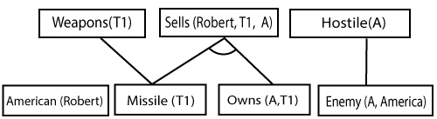

**Step-3:**

At step-3, as we can check Rule-(1) is satisfied with the substitution **{p/Robert, q/T1, r/A}, so we can add Criminal(Robert)** which infers all the available facts. And hence we reached our goal statement.

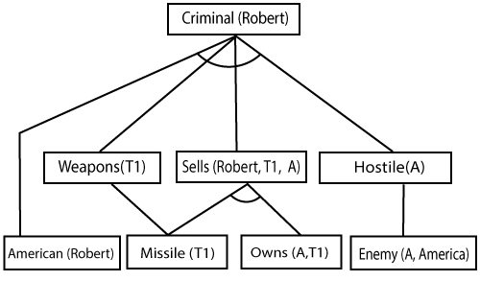

**Hence it is proved that Robert is Criminal using forward chaining approach.**

## **B. Backward Chaining:**

Backward-chaining is also known as a backward deduction or backward reasoning method when using an inference engine. A backward chaining algorithm is a form of reasoning, which starts with the goal and works backward, chaining through rules to find known facts that support the goal.

**Properties of backward chaining:**

* It is known as a top-down approach.
* Backward-chaining is based on modus ponens inference rule.
* In backward chaining, the goal is broken into sub-goal or sub-goals to prove the facts true.
* It is called a goal-driven approach, as a list of goals decides which rules are selected and used.
* Backward -chaining algorithm is used in game theory, automated theorem proving tools, inference engines, proof assistants, and various AI applications.
* The backward-chaining method mostly used a **depth-first search** strategy for proof.

### **Example:**

In backward-chaining, we will use the same above example, and will rewrite all the rules.

* **American (p) ∧ weapon(q) ∧ sells (p, q, r) ∧ hostile(r) → Criminal(p) ...(1)**  
  **Owns(A, T1)                 ........(2)**
* **Missile(T1)**
* **?p Missiles(p) ∧ Owns (A, p) → Sells (Robert, p, A)           ......(4)**
* **Missile(p) → Weapons (p)                 .......(5)**
* **Enemy(p, America) →Hostile(p)                 ........(6)**
* **Enemy (A, America)                 .........(7)**
* **American(Robert).                 ..........(8)**

## **Backward-Chaining proof:**

In Backward chaining, we will start with our goal predicate, which is **Criminal(Robert)**, and then infer further rules.

**Step-1:**

At the first step, we will take the goal fact. And from the goal fact, we will infer other facts, and at last, we will prove those facts true. So our goal fact is "Robert is Criminal," so following is the predicate of it.

Forward Chaining and backward chaining in AI

**Step-2:**

At the second step, we will infer other facts form goal fact which satisfies the rules. So as we can see in Rule-1, the goal predicate Criminal (Robert) is present with substitution {Robert/P}. So we will add all the conjunctive facts below the first level and will replace p with Robert.

**Here we can see American (Robert) is a fact, so it is proved here.**

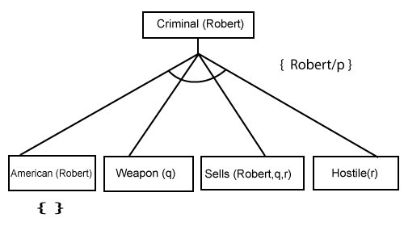

**Step-3:**t At step-3, we will extract further fact Missile(q) which infer from Weapon(q), as it satisfies Rule-(5). Weapon (q) is also true with the substitution of a constant T1 at q.

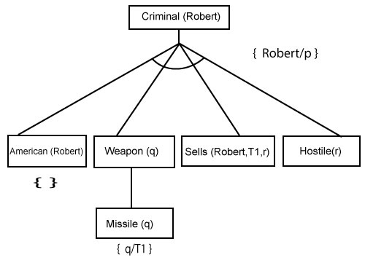

**Step-4:**

At step-4, we can infer facts Missile(T1) and Owns(A, T1) form Sells(Robert, T1, r) which satisfies the **Rule- 4**, with the substitution of A in place of r. So these two statements are proved here.

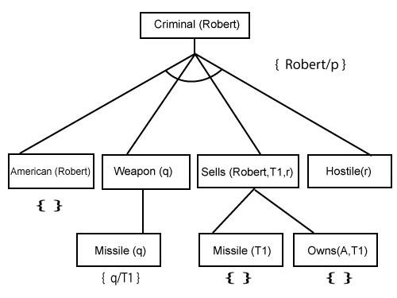

**Step-5:**

At step-5, we can infer the fact **Enemy(A, America)** from **Hostile(A)** which satisfies Rule- 6. And hence all the statements are proved true using backward chaining.

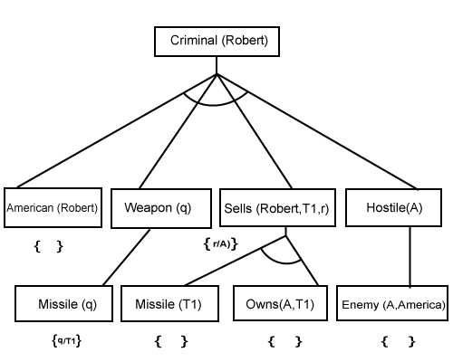

# Resolution in FOL

## **Resolution**

Resolution is a theorem proving technique that proceeds by building refutation proofs, i.e., proofs by contradictions. It was invented by a Mathematician John Alan Robinson in the year 1965.

Resolution is used, if there are various statements are given, and we need to prove a conclusion of those statements. Unification is a key concept in proofs by resolutions. Resolution is a single inference rule which can efficiently operate on the **conjunctive normal form or clausal form**.

**Clause**: Disjunction of literals (an atomic sentence) is called a **clause**. It is also known as a unit clause.

**Conjunctive Normal Form**: A sentence represented as a conjunction of clauses is said to be **conjunctive normal form** or **CNF**.

ADVERTISEMENT

#### **Note: To better understand this topic, firstly learns the FOL in AI.**

## **The resolution inference rule:**

The resolution rule for first-order logic is simply a lifted version of the propositional rule. Resolution can resolve two clauses if they contain complementary literals, which are assumed to be standardized apart so that they share no variables.

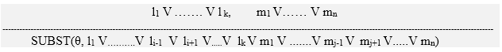

Where **li** and **mj** are complementary literals.

This rule is also called the **binary resolution rule** because it only resolves exactly two literals.

### **Example:**

We can resolve two clauses which are given below:

**[Animal (g(x) V Loves (f(x), x)]       and       [￢ Loves(a, b) V ￢Kills(a, b)]**

Where two complimentary literals are: **Loves (f(x), x) and ￢ Loves (a, b)**

These literals can be unified with unifier **θ= [a/f(x), and b/x]**, and it will generate a resolvent clause:

**[Animal (g(x) V ￢ Kills(f(x), x)].**

## **Steps for Resolution:**

1. Conversion of facts into first-order logic.
2. Convert FOL statements into CNF
3. Negate the statement which needs to prove (proof by contradiction)
4. Draw resolution graph (unification).

To better understand all the above steps, we will take an example in which we will apply resolution.

### **Example:**

1. **John likes all kind of food.**
2. **Apple and vegetable are food**
3. **Anything anyone eats and not killed is food.**
4. **Anil eats peanuts and still alive**
5. **Harry eats everything that Anil eats.**  
   **Prove by resolution that:**
6. **John likes peanuts.**

**Step-1: Conversion of Facts into FOL**

In the first step we will convert all the given statements into its first order logic.

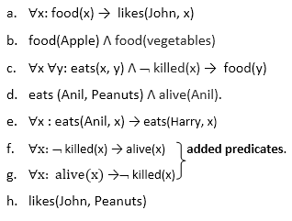

**Step-2: Conversion of FOL into CNF**

In First order logic resolution, it is required to convert the FOL into CNF as CNF form makes easier for resolution proofs.

* **Eliminate all implication (→) and rewrite**
  1. ∀x ¬ food(x) V likes(John, x)
  2. food(Apple) Λ food(vegetables)
  3. ∀x ∀y ¬ [eats(x, y) Λ ¬ killed(x)] V food(y)
  4. eats (Anil, Peanuts) Λ alive(Anil)
  5. ∀x ¬ eats(Anil, x) V eats(Harry, x)
  6. ∀x¬ [¬ killed(x) ] V alive(x)
  7. ∀x ¬ alive(x) V ¬ killed(x)
  8. likes(John, Peanuts).
* **Move negation (¬)inwards and rewrite**
  1. ∀x ¬ food(x) V likes(John, x)
  2. food(Apple) Λ food(vegetables)
  3. ∀x ∀y ¬ eats(x, y) V killed(x) V food(y)
  4. eats (Anil, Peanuts) Λ alive(Anil)
  5. ∀x ¬ eats(Anil, x) V eats(Harry, x)
  6. ∀x ¬killed(x) ] V alive(x)
  7. ∀x ¬ alive(x) V ¬ killed(x)
  8. likes(John, Peanuts).
* **Rename variables or standardize variables**
  1. ∀x ¬ food(x) V likes(John, x)
  2. food(Apple) Λ food(vegetables)
  3. ∀y ∀z ¬ eats(y, z) V killed(y) V food(z)
  4. eats (Anil, Peanuts) Λ alive(Anil)
  5. ∀w¬ eats(Anil, w) V eats(Harry, w)
  6. ∀g ¬killed(g) ] V alive(g)
  7. ∀k ¬ alive(k) V ¬ killed(k)
  8. likes(John, Peanuts).
* **Eliminate existential instantiation quantifier by elimination.**  
  In this step, we will eliminate existential quantifier ∃, and this process is known as **Skolemization**. But in this example problem since there is no existential quantifier so all the statements will remain same in this step.
* **Drop Universal quantifiers.**  
  In this step we will drop all universal quantifier since all the statements are not implicitly quantified so we don't need it.
  1. ¬ food(x) V likes(John, x)
  2. food(Apple)
  3. food(vegetables)
  4. ¬ eats(y, z) V killed(y) V food(z)
  5. eats (Anil, Peanuts)
  6. alive(Anil)
  7. ¬ eats(Anil, w) V eats(Harry, w)
  8. killed(g) V alive(g)
  9. ¬ alive(k) V ¬ killed(k)
  10. likes(John, Peanuts).

#### **Note: Statements "food(Apple) Λ food(vegetables)" and "eats (Anil, Peanuts) Λ alive(Anil)" can be written in two separate statements.**

* **Distribute conjunction ∧ over disjunction ¬.**  
  This step will not make any change in this problem.

**Step-3: Negate the statement to be proved**

In this statement, we will apply negation to the conclusion statements, which will be written as ¬likes(John, Peanuts)

**Step-4: Draw Resolution graph:**

Now in this step, we will solve the problem by resolution tree using substitution. For the above problem, it will be given as follows:

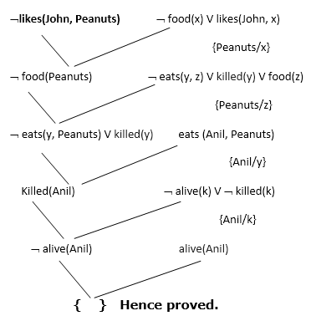

Hence the negation of the conclusion has been proved as a complete contradiction with the given set of statements.

## **Explanation of Resolution graph:**

* In the first step of resolution graph, **¬likes(John, Peanuts)**, and **likes(John, x)**get resolved(canceled) by substitution of **{Peanuts/x}**, and we are left with **¬ food(Peanuts)**
* In the second step of the resolution graph, **¬ food(Peanuts)**, and **food(z)**get resolved (canceled) by substitution of **{ Peanuts/z}**, and we are left with **¬ eats(y, Peanuts) V killed(y)**.
* In the third step of the resolution graph, **¬ eats(y, Peanuts)**and **eats (Anil, Peanuts)**get resolved by substitution **{Anil/y}**, and we are left with **Killed(Anil)**.
* In the fourth step of the resolution graph, **Killed(Anil)**and **¬ killed(k)**get resolve by substitution **{Anil/k}**, and we are left with **¬ alive(Anil)**.
* In the last step of the resolution graph **¬ alive(Anil)**and **alive(Anil)**get resolved.

# What is knowledge representation?

Humans are best at understanding, reasoning, and interpreting knowledge. Human knows things, which is knowledge and as per their knowledge they perform various actions in the real world. **But how machines do all these things comes under knowledge representation and reasoning**. Hence we can describe Knowledge representation as following:

* Knowledge representation and reasoning (KR, KRR) is the part of Artificial intelligence which concerned with AI agents thinking and how thinking contributes to intelligent behavior of agents.
* It is responsible for representing information about the real world so that a computer can understand and can utilize this knowledge to solve the complex real world problems such as diagnosis a medical condition or communicating with humans in natural language.
* It is also a way which describes how we can represent knowledge in artificial intelligence. Knowledge representation is not just storing data into some database, but it also enables an intelligent machine to learn from that knowledge and experiences so that it can behave intelligently like a human.

## **What to Represent:**

Following are the kind of knowledge which needs to be represented in AI systems:

* **Object:** All the facts about objects in our world domain. E.g., Guitars contains strings, trumpets are brass instruments.
* **Events:** Events are the actions which occur in our world.
* **Performance:** It describe behavior which involves knowledge about how to do things.
* **Meta-knowledge:** It is knowledge about what we know.
* **Facts:** Facts are the truths about the real world and what we represent.
* **Knowledge-Base:** The central component of the knowledge-based agents is the knowledge base. It is represented as KB. The Knowledgebase is a group of the Sentences (Here, sentences are used as a technical term and not identical with the English language).

**Knowledge:** Knowledge is awareness or familiarity gained by experiences of facts, data, and situations. Following are the types of knowledge in artificial intelligence:

## **Types of knowledge**

Following are the various types of knowledge:

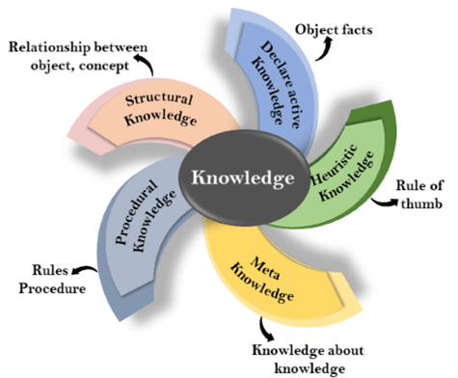

**1. Declarative Knowledge:**

* Declarative knowledge is to know about something.
* It includes concepts, facts, and objects.
* It is also called descriptive knowledge and expressed in declarativesentences.
* It is simpler than procedural language.

**2. Procedural Knowledge**

* It is also known as imperative knowledge.
* Procedural knowledge is a type of knowledge which is responsible for knowing how to do something.
* It can be directly applied to any task.
* It includes rules, strategies, procedures, agendas, etc.
* Procedural knowledge depends on the task on which it can be applied.

**3. Meta-knowledge:**

* Knowledge about the other types of knowledge is called Meta-knowledge.

**4. Heuristic knowledge:**

* Heuristic knowledge is representing knowledge of some experts in a filed or subject.
* Heuristic knowledge is rules of thumb based on previous experiences, awareness of approaches, and which are good to work but not guaranteed.

**5. Structural knowledge:**

* Structural knowledge is basic knowledge to problem-solving.
* It describes relationships between various concepts such as kind of, part of, and grouping of something.
* It describes the relationship that exists between concepts or objects.

## **The relation between knowledge and intelligence:**

Knowledge of real-worlds plays a vital role in intelligence and same for creating artificial intelligence. Knowledge plays an important role in demonstrating intelligent behavior in AI agents. An agent is only able to accurately act on some input when he has some knowledge or experience about that input.

Let's suppose if you met some person who is speaking in a language which you don't know, then how you will able to act on that. The same thing applies to the intelligent behavior of the agents.

As we can see in below diagram, there is one decision maker which act by sensing the environment and using knowledge. But if the knowledge part will not present then, it cannot display intelligent behavior.

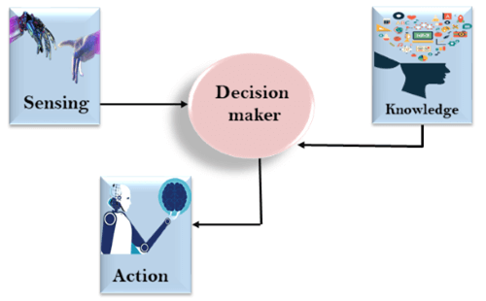

## **AI knowledge cycle:**

An Artificial intelligence system has the following components for displaying intelligent behavior:

* Perception
* Learning
* Knowledge Representation and Reasoning
* Planning
* Execution

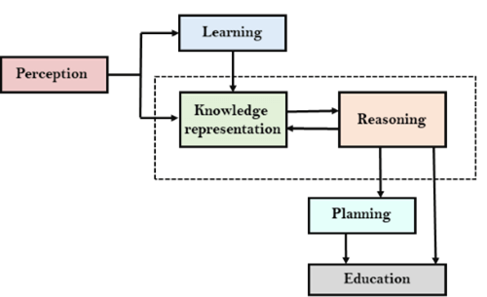

The above diagram is showing how an AI system can interact with the real world and what components help it to show intelligence. AI system has Perception component by which it retrieves information from its environment. It can be visual, audio or another form of sensory input. The learning component is responsible for learning from data captured by Perception comportment. In the complete cycle, the main components are knowledge representation and Reasoning. These two components are involved in showing the intelligence in machine-like humans. These two components are independent with each other but also coupled together. The planning and execution depend on analysis of Knowledge representation and reasoning.

## **Approaches to knowledge representation:**

There are mainly four approaches to knowledge representation, which are givenbelow:

### **1. Simple relational knowledge:**

* It is the simplest way of storing facts which uses the relational method, and each fact about a set of the object is set out systematically in columns.
* This approach of knowledge representation is famous in database systems where the relationship between different entities is represented.
* This approach has little opportunity for inference.

**Example: The following is the simple relational knowledge representation.**

|  |  |  |
| --- | --- | --- |
| **Player** | **Weight** | **Age** |
| Player1 | 65 | 23 |
| Player2 | 58 | 18 |
| Player3 | 75 | 24 |

### **2. Inheritable knowledge:**

* In the inheritable knowledge approach, all data must be stored into a hierarchy of classes.
* All classes should be arranged in a generalized form or a hierarchal manner.
* In this approach, we apply inheritance property.
* Elements inherit values from other members of a class.
* This approach contains inheritable knowledge which shows a relation between instance and class, and it is called instance relation.
* Every individual frame can represent the collection of attributes and its value.
* In this approach, objects and values are represented in Boxed nodes.
* We use Arrows which point from objects to their values.
* **Example:**

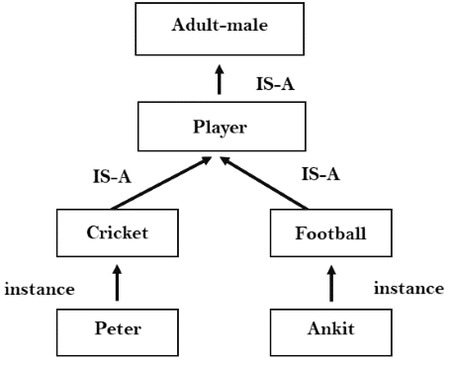

### **3. Inferential knowledge:**

* Inferential knowledge approach represents knowledge in the form of formal logics.
* This approach can be used to derive more facts.
* It guaranteed correctness.
* **Example:** Let's suppose there are two statements:
  1. Marcus is a man
  2. All men are mortal  
     Then it can represent as;  
       
     **man(Marcus)  
     ∀x = man (x) ----------> mortal (x)s**

### **4. Procedural knowledge:**

* Procedural knowledge approach uses small programs and codes which describes how to do specific things, and how to proceed.
* In this approach, one important rule is used which is **If-Then rule**.
* In this knowledge, we can use various coding languages such as **LISP language** and **Prolog language**.
* We can easily represent heuristic or domain-specific knowledge using this approach.
* But it is not necessary that we can represent all cases in this approach.

## **Requirements for knowledge Representation system:**

A good knowledge representation system must possess the following properties.

1. **1. Representational Accuracy:**  
   KR system should have the ability to represent all kind of required knowledge.
2. **2. Inferential Adequacy:**  
   KR system should have ability to manipulate the representational structures to produce new knowledge corresponding to existing structure.
3. **3. Inferential Efficiency:**  
   The ability to direct the inferential knowledge mechanism into the most productive directions by storing appropriate guides.
4. **4. Acquisitional efficiency-** The ability to acquire the new knowledge easily using automatic methods.

# Introduction to Ontologies

**Ontologies** are formal definitions of vocabularies that allow us to define difficult or complex structures and new relationships between vocabulary terms and members of classes that we define. Ontologies generally describe specific domains such as scientific research areas.

**Example:**  
Ontology depicting Movie:-

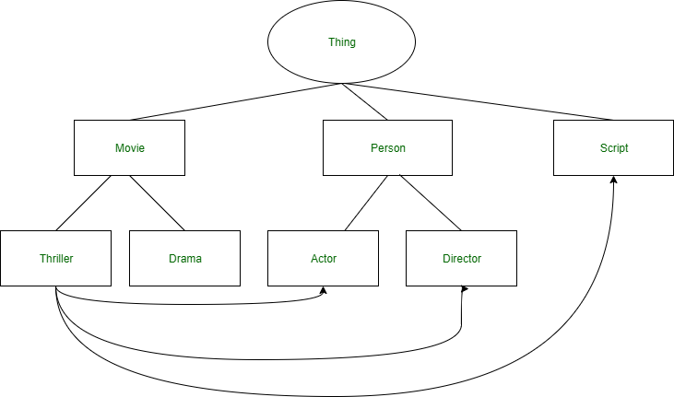

**Components:**

1. **Individuals –**  
   Individuals are also known as instances of objects or concepts.It may or may not be present in an ontology.It represents the atomic level of an ontology.

For example, in the above ontology of movie, individuals can be a film (Titanic), a director (James Cameron), an actor (Leonardo DiCaprio).

1. **Classes –**  
   Sets of collections of various objects are termed as classes.

For example, in the above ontology representing movie, movie genre (e.g. Thriller, Drama), types of person (Actor or Director) are classes.

1. **Attributes –**  
   Properties that objects may possess.

For example, a movie is described by the set of ‘parts’ it contains like Script, Director, Actors.

1. **Relations –**  
   Ways in which concepts are related to one another.

For example, as shown above in the diagram a movie has to have a script and actors in it.

**Different Ontology Languages:**

* **CycL –** It was developed for the Cyc project and is based on First Order Predicate Calculus.
* **Rule Interchange Format (RIF) –** It is the language used for combining ontologies and rules.
* **Open Biomedical Ontologies (OBO) –** It is used for various biological and biomedical ontologies.
* **Web Ontology Language (OWL) –** It is developed for using ontologies over the [World Wide Web (WWW)](https://www.geeksforgeeks.org/world-wide-web-www/).